**Generator**

**Instruction:**

* This HTML5 app simulates a generator which is reduced to the most important parts for clarity. Instead of an armature with many windings and iron nucleus there is only a single rectangular conductor loop; the axis the loop rotates on is omitted.
* The radio buttons in the top right corner allow you to choose an AC generator (without commutator), or a DC generator (with commutator).

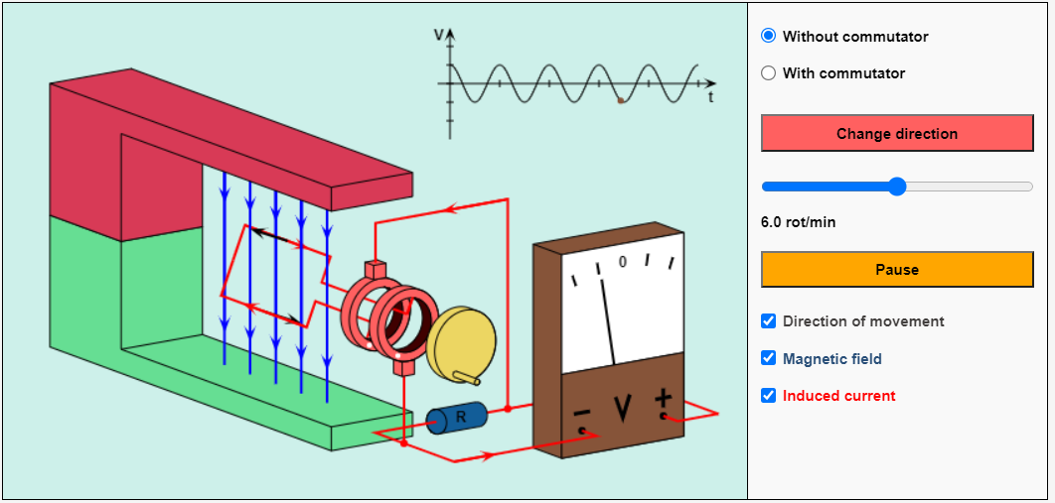

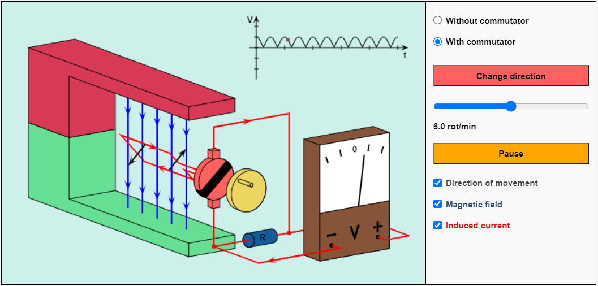

* You can change the direction of rotation by using the corresponding button.

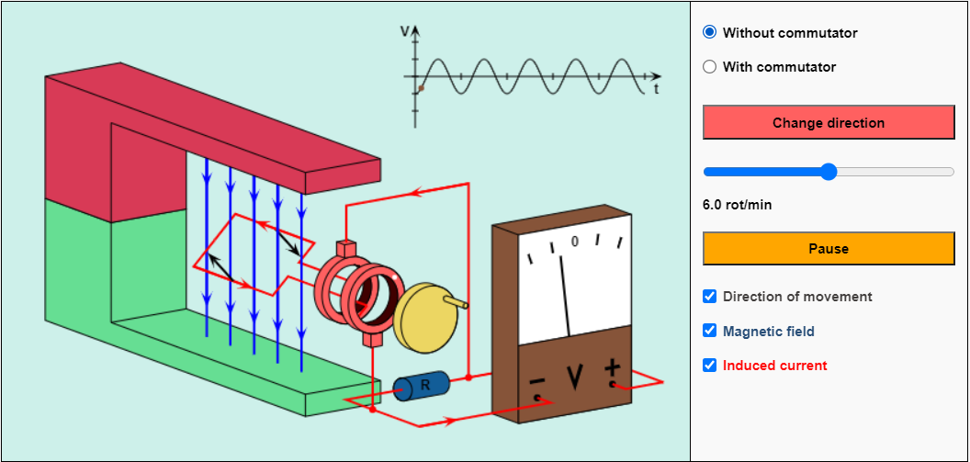

* You can stop and continue the simulation with the button "Pause / Resume".This, however, does *not* mean a real stop of the movement, for in this case the induced voltage would be reduced to zero.

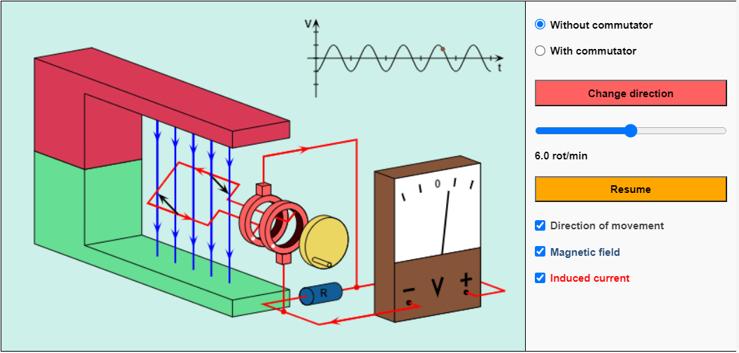

* Two black arrows mark the momentary direction of movement.You can recognize the magnetic field lines (directed from the red painted north pole to the green painted south pole) by the blue color.
* The red arrows represent the direction of the induced current (conventional direction of current).